Building a Data Lake for Food Analytics with AWS Athena, S3, Glue, and SQL from USDA API Data
Autumn Hicks
Jan 15, 2025
In the fast-paced world of food service, accurate ingredient data is crucial for effective inventory management, menu planning, and purchasing decisions. For those in quality assurance and production management, having access to detailed product information — including ingredients, nutrition, and sourcing — can drastically impact operational efficiency. For example, I have faced the challenge of supplier ingredient changes, which affected our own company’s packaged goods labels. Having a reliable and easily searchable database helps QA teams to “trust but verify” ingredient accuracy — vital for food safety.
In this article, I will walk you through the journey of building a data lake for food analytics using AWS Athena, Glue, S3, and utilizing SQL queries to analyze data. This project pulls data from the USDA API, cleans it, and stores it in a scalable, queryable format, enabling us to gain valuable insights about the ingredients in food products. By the end, you’ll be able to efficiently query and analyze a variety of food-related data.
Step 1: Requesting an API Key from the USDA and Setting Up IAM Roles
The first step in building the food analytics data lake is to fetch data from the USDA API. To do this, you need an API key from the USDA, which is used to authenticate your requests to the API. Follow these steps to get your API key and securely store it for use in the script.
Requesting the USDA API Key
To pull data from the USDA’s Food Data Central API, you’ll first need to request an API key. Here’s how to do that:
- Go to the USDA Food Data Central API portal:
- Visit USDA Food Data Central API.
- Sign up for an API key by following the steps on the website.
- Once you’ve signed up, you’ll receive an email with the key, which you can use to authenticate requests.
2. Store the API Key Securely: It’s a best practice to keep sensitive information like API keys secure. For this, use environment variables or a .env file. Here's how to do this:
- In your CloudShell environment, create a .env file and store the API key:
nano .env
- Add the following line to the file:
USDA_API_KEY=your_api_key_here
- After saving the .env file, use the python-dotenv library to load the API key in your Python script. This keeps your credentials secure and out of the source code.
Setting Up IAM Roles and Users for Best Practices
To properly handle permissions and secure your AWS resources, you’ll need to set up IAM (Identity and Access Management) roles and users with appropriate permissions.
- Create an IAM User:
- Go to the AWS IAM Console.
- Click on Users from the left sidebar and then click on Add user.
- Give the user a name like usda-api-access, and select Programmatic access to allow access to AWS services via API.
- Create and Attach Permissions:
- On the Set permissions page, choose Attach policies directly and select the following policies:
- AmazonS3FullAccess — To give the user full access to S3 (for uploading and managing files).
- AWSGlueServiceRole — For Glue-related permissions, including crawling and creating tables.
- AmazonAthenaFullAccess — To allow access to Athena for querying the data stored in S3.
- You can also create custom policies if you need more granular control over the permissions.
- Create an IAM Role for Glue:
- Navigate to Roles in the IAM Console and click on Create role.
- Choose AWS service as the trusted entity, then select Glue.
- Attach the necessary policies, such as AWSGlueServiceRole and AmazonS3FullAccess, to the role.
- Give it a name like GlueDataProcessingRole.
- Create an IAM Role for Lambda (if using): If you plan to automate the process using AWS Lambda, ensure that Lambda has the necessary permissions. You can use a role like AWSLambdaBasicExecutionRole and attach AmazonS3FullAccess and AWSGlueServiceRole for Lambda to interact with S3 and Glue.
- Best Practices for IAM Roles and Permissions:
- Least Privilege: Always follow the principle of least privilege by granting only the permissions required for a given task.
- Rotate Credentials Regularly: Make sure API keys and other credentials are rotated periodically.
- Use MFA: Enable Multi-Factor Authentication (MFA) for your IAM users to add an extra layer of security.
Step 2: Setting Up and Running the CloudShell Python Script
In this step, we’ll focus on setting up the Python script in AWS CloudShell, pulling data from the USDA API, handling pagination, and parsing it into a manageable format for uploading to S3. This avoids large file sizes that would be difficult to work with later in the process.
Setting Up the CloudShell Python Script
To begin, you’ll set up a Python script that fetches data from the USDA API, with a focus on pagination and reducing the data size by parsing only the essential fields: foodName, brand, and ingredients.
- Create the Python Script:
- Open AWS CloudShell from the AWS Management Console.
- In CloudShell, create a new Python file:
nano setup_usda_data_lake.py
- Importing Required Libraries: You’ll need the following libraries to work with the USDA API and S3:
import os
import requests
from dotenv import load_dotenv
import json
import boto3
from time import sleep
- Loading API Key from Environment: To keep your API key secure, it’s loaded from a .env file:
load_dotenv() api_key = os.getenv("USDA_API_KEY") usda_endpoint = "https://api.nal.usda.gov/fdc/v1/foods/search"
- Fetching Data with Pagination: The following function fetches data from the USDA API while handling pagination. We ensure that we don’t exceed 2000 pages, and we process only 25 results per page.
def fetch_all_food_data(
query="*",
data_type="Branded",
page_size=25,
max_pages=2000
):
all_data = []
page_number = 1
while page_number <= max_pages:
url = f"{usda_endpoint}?query={query}&dataType={data_type}&pageSize={page_size}&pageNumber={page_number}&sortBy=publishedDate&sortOrder=desc&api_key={api_key}"
print(f"Fetching page {page_number}...")
try:
response = requests.get(url)
response.raise_for_status()
data = response.json()
if not data.get('foods'):
break
for food_item in data.get("foods", []):
food_info = {
"foodName": food_item.get("description", ""),
"brand": food_item.get("brandOwner", ""),
"ingredients": food_item.get("ingredients", ""),
"nutrients": [
{
"name": nutrient.get("name", ""),
"amount": nutrient.get("amount", ""),
"unit": nutrient.get("unitName", ""),
"derivationCode": nutrient.get("derivationCode", ""),
"derivationDescription": nutrient.get("derivationDescription", "")
}
for nutrient in food_item.get("foodNutrients", [])
],
"publicationDate": food_item.get("publicationDate", "")
}
all_data.append(food_info)
if len(all_data) > 100000:
break # Limit the data size
page_number += 1
sleep(2) # Prevent hitting API rate limits
except requests.exceptions.RequestException as req_err:
print(f"Request error: {req_err}")
break
return all_data
- Uploading Data to S3: After fetching and parsing the data, this snippet uploads it to your S3 bucket:
s3_client = boto3.client('s3')
bucket_name = 'usda-analytics-data-lake'
def upload_data_to_s3(data):
try:
file_key = "raw-data/usda_data.json" # Define the path to store the file
# Upload data to S3
s3_client.put_object(
Bucket=bucket_name,
Key=file_key,
Body=json.dumps(data)
)
print(f"Data uploaded to {bucket_name}/{file_key}")
except Exception as e:
print(f"Error uploading data: {e}")
Running the Script in CloudShell
Once you’ve created your setup_usda_data_lake.py script, follow these steps to run it in AWS CloudShell:
Run the Script:
Once your environment variables are set up, run the Python script:
python3 setup_usda_data_lake.py
The script will fetch data from the USDA API, clean and filter the necessary information, and then upload the results to your S3 bucket.
The USDA API can provide large datasets and it was failing for me after 50,000 records. By using pagination, this script requests a manageable number of records per page (25 per page) and fetches up to 2000 pages. This helps keep the file size within limits, making it more practical for subsequent processing. Feel free to adjust this!
Press enter or click to view image in full size
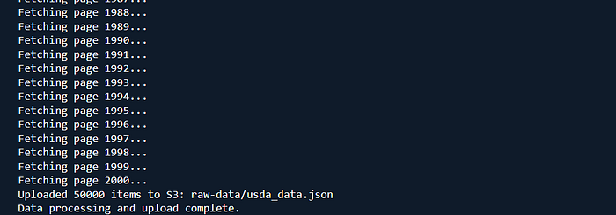
Step 3: Setting Up AWS Glue Crawler to Create the Table
Once the data is uploaded to S3, you can use AWS Glue to create a table schema based on the data format. Glue’s Crawler automatically infers the schema and makes it easy to query the data in Athena.
Here’s how to configure the Glue Crawler:
- In the AWS Glue Console, create a new Crawler.
- Select your data store as S3 and provide the S3 path to your raw data file in the raw-data folder.
- Define the output database and table in Glue.
- Choose an IAM role for Glue that has access to your S3 data.
- Run the Crawler to automatically create the table with the inferred schema.
Once the Crawler finishes, you can use Athena to query the data directly.
Step 4: Setting Up Athena for SQL Queries
Now that the data is stored in S3 and the schema is created with Glue, it’s time to query the data. Athena allows you to run SQL queries on your S3 data, and since the Glue Crawler created a schema for the data, you can start querying right away.
Here’s an example SQL query to search for food products containing almond flour:
SELECT foodName, brand, ingredients
FROM "usda_data_lake"."food_data"
WHERE ingredients LIKE '%almond flour%'
LIMIT 10;
Athena queries allow you to quickly pull valuable insights from the data, such as finding all products with a certain ingredient or searching for brands of a specific food item.
Step 5: Querying Food Data with Athena
Now that everything was set up, I could run SQL queries in Athena to find products with specific ingredients or brands. Here are a few example queries to help you get started:
Search for ‘vegetable stock’ or ‘broth’ (all brands)
SELECT * FROM usda_data_lake_table WHERE foodname LIKE '%VEGETABLE STOCK%' OR '%BROTH%';
Press enter or click to view image in full size
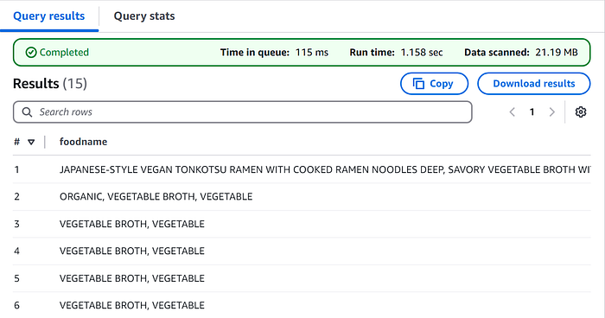
Search for ‘non-fat yogurt’ (all brands)
SELECT * FROM usda_data_lake_table WHERE foodname LIKE '%NONFAT YOGURT%';
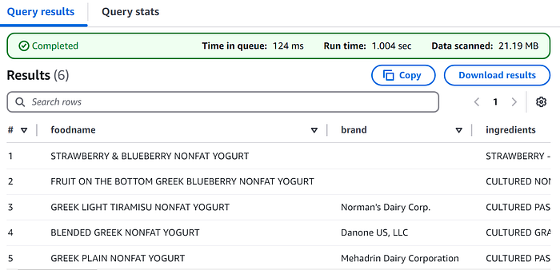
Search for ‘tomato sauce’ (all brands)
SELECT * FROM usda_data_lake_table WHERE foodname LIKE '%TOMATO SAUCE%';
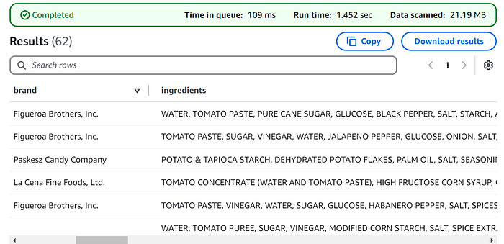
Search for a specific brand of ketchup:
SELECT *
FROM usda_data_lake
WHERE brand LIKE '%Kraft Heinz%' AND foodname LIKE '%KETCHUP%'
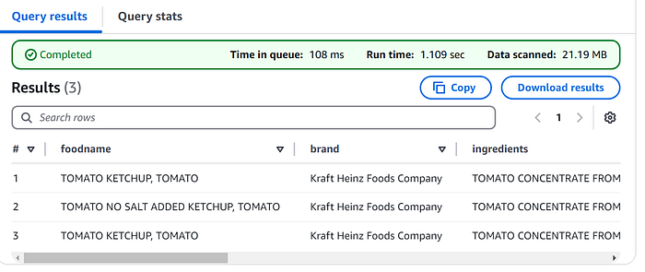
Step 6: Automating the Process with AWS Lambda and EventBridge (Optional)
For regular updates, you can automate the entire data-fetching pipeline. Using AWS Lambda, you can schedule periodic data pulls from the USDA API, ensuring that your data is always up-to-date. You can configure EventBridge to trigger Lambda functions periodically, so new data is pulled, processed, and uploaded to your S3 bucket without manual intervention.
Troubleshooting: Restructuring the Data in CloudShell with jq
After uploading the raw USDA data to S3, I encountered an issue where the Glue Crawler could not properly detect the schema. This was due to the original JSON file being structured as an array of objects, which caused problems for the crawler when trying to create a table. I unsuccessfully tried an ETL Job to fix this issue, but it didn’t work.
To resolve this, I used CloudShell along with the jq command-line tool to unpack the array into individual objects. This restructuring allowed AWS Glue to correctly detect the schema and create the table in Athena.
Here’s how I approached the issue:
- Identifying the Problem:
- The original USDA JSON data was structured like this:
[
{
"foodName": "Example Food",
"brand": "Example Brand",
"ingredients": "ingredient1, ingredient2",
"nutrients": [
{ ... },
{ ... }
],
"publicationDate": "2021-01-01"
},
{ ... }
]
The data was contained in an array, and AWS Glue had difficulty processing it due to this structure. To solve this, I used jq to unpack the array and output each item as a separate object, so Glue could process it. I ran the following command in CloudShell:
jq -c '.[]' usda_data.json > reformatted_usda_data.json
Explanation:
- jq -c '.[]': This command extracts each element from the array in the JSON file and outputs it as a single-line, flat structure (using the -c option for compact output).
Maybe you are able to improve the script to avoid this issue in the future (I encourage you to), for now this was my fix!

